Journal of Climate Change

About the Journal:
The Journal of Climate Change is an international, peer-reviewed platform dedicated to advancing research on climate science, environmental sustainability, and the global impacts of climate variability. The journal publishes innovative research articles, reviews, case studies, and perspectives covering climate systems, environmental challenges, adaptation strategies, and solutions for building a resilient future.
The journal provides a multidisciplinary forum for scientists, researchers, policymakers, and environmental professionals to explore the complex interactions between climate change, ecosystems, society, and human health. It highlights emerging developments in climate mitigation, renewable energy, sustainable development, climate policy, and innovative approaches to addressing the challenges of a rapidly changing global environment.
Latest News:
Global Heat Extremes Raise Concerns as 2026 Approaches Hottest Years on Record:-
Rising global temperatures, record ocean heat levels, and widespread heatwaves are increasing concerns among climate scientists about the accelerating impacts of climate change. Researchers warn that the combination of greenhouse gas emissions and emerging El Niño conditions could push global temperatures toward unprecedented levels, creating major challenges for ecosystems, public health, and climate adaptation strategies.
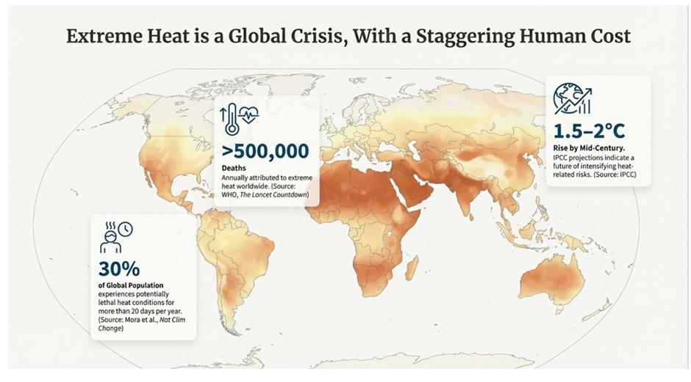
Climate Adaptation Becomes a Global Priority as Extreme Weather Intensifies:-
Governments and communities worldwide are strengthening climate adaptation strategies to manage increasing risks from floods, wildfires, hurricanes, and extreme heat events. New resilience initiatives focus on climate-ready infrastructure, disaster preparedness, sustainable urban planning, and protecting vulnerable populations from future climate impacts.
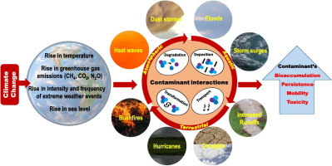

Ocean Warming and Marine Ecosystem Changes Threaten Coastal Biodiversity:-
Rising ocean temperatures and increasing marine heatwaves are accelerating changes in marine ecosystems, affecting coral reefs, fisheries, and coastal biodiversity. Researchers are investigating ocean warming patterns, ecosystem adaptation, and conservation strategies to protect marine environments under changing climate conditions.
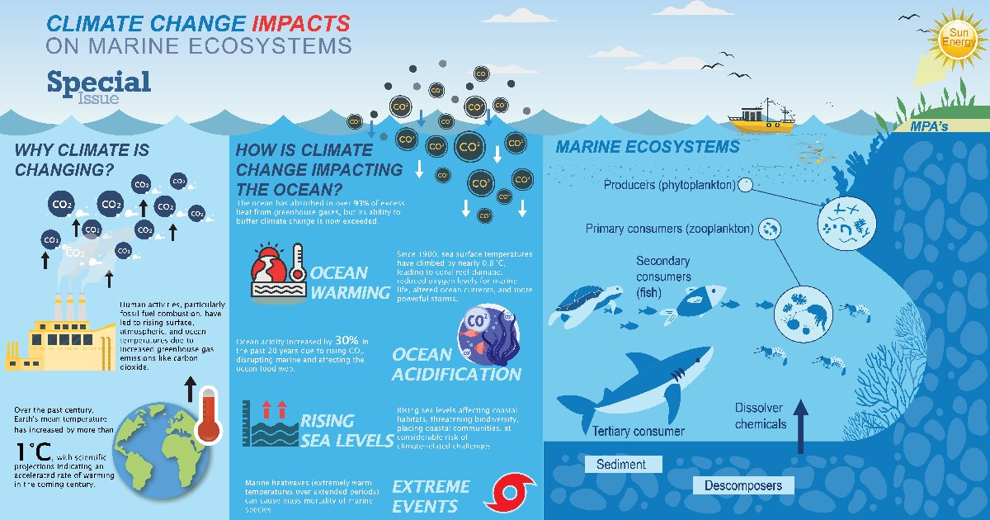
Renewable Energy Expansion Accelerates Global Climate Mitigation Efforts:-
Global investments in renewable energy technologies continue to expand as countries strengthen efforts to reduce greenhouse gas emissions and achieve climate targets. Advances in solar power, wind energy, energy storage, and sustainable technologies are playing a critical role in transitioning toward low-carbon energy systems.
Scientific Topics:

1. Atmospheric Changes
Explores atmospheric composition, climate variability, air quality changes, and interactions between atmospheric processes and global climate systems. The session highlights advances in climate research, monitoring techniques, and scientific approaches to understanding changes in the Earth’s atmosphere.
2. Biodiversity and Biological Conservation
Focuses on ecosystem diversity, species protection, habitat restoration, and the impacts of climate change on biological systems. The session highlights innovative conservation strategies that support ecological balance and long-term environmental sustainability.
3. Climate and Energy Policy
Examines renewable energy transitions, climate governance, energy regulations, and sustainable policy frameworks. The session highlights strategies for developing low-carbon energy systems and achieving global climate objectives.
4. Climate Change Adaptation
Explores climate resilience, adaptive technologies, community-based solutions, and strategies for managing climate risks. The session highlights approaches that strengthen societies, ecosystems, and infrastructure against future climate challenges.
5. Climate Change and Health
Focuses on climate-related health risks, environmental diseases, heat impacts, and public health adaptation strategies. The session highlights research addressing the relationship between climate change and human health protection.
6. Indigenous Climate Monitoring and Mitigation
Examines indigenous knowledge systems, traditional ecological practices, climate monitoring approaches, and community-led mitigation efforts. The session highlights the important role of indigenous communities in developing sustainable climate solutions.
7. CO₂, Emissions, Capture and Sequestration
Explores carbon dioxide emissions, carbon capture technologies, storage solutions, and greenhouse gas reduction strategies. The session highlights innovative approaches supporting carbon management and global net-zero initiatives.
8. Disaster Management
Focuses on climate-related disasters, emergency preparedness, risk assessment, and disaster response strategies. The session highlights scientific and practical approaches to improving resilience against environmental hazards.
9. Ecology and Ecosystems
Examines ecosystem dynamics, environmental interactions, habitat changes, and climate-driven ecological transformations. The session highlights research supporting ecosystem protection, restoration, and sustainable environmental management.
10. Emissions and Control
Explores emission monitoring, pollution reduction technologies, greenhouse gas control, and sustainable environmental practices. The session highlights solutions aimed at reducing environmental impacts and improving climate sustainability.
11. Climate Change Law & Policy
Focuses on environmental regulations, climate legislation, international agreements, and governance frameworks. The session highlights legal and policy approaches that support effective climate action and sustainable development.
12. Geothermal Power & Heat
Examines geothermal energy resources, heat extraction technologies, renewable applications, and energy efficiency solutions. The session highlights the role of geothermal systems in supporting clean energy transitions.
13. Global Climate Strategies and Policies
Explores international climate initiatives, sustainability frameworks, mitigation programs, and collaborative environmental policies. The session highlights global efforts to address climate challenges through coordinated action.
14. Global Warming Modelling/Simulation
Focuses on climate modelling, simulation techniques, predictive analysis, and future climate projections. The session highlights advanced research methods for understanding climate patterns and forecasting environmental changes.
15. Green Technology and Green Production
Explores sustainable technologies, eco-friendly manufacturing, circular economy practices, and resource-efficient production methods. The session highlights innovations that reduce environmental impact and promote sustainable industrial development.
16. Greenhouse Gases and Emissions
Examines greenhouse gas sources, emission patterns, atmospheric impacts, and mitigation approaches. The session highlights scientific research and technological solutions for controlling emissions and addressing global warming.
17. Natural Hazards and Disaster Management
Focuses on floods, wildfires, storms, extreme weather events, risk assessment, and emergency preparedness. The session highlights strategies for improving disaster resilience and protecting communities from climate-related hazards.
18. Sea-Level Rise, Oceans and Climate
Explores ocean warming, sea-level rise, marine ecosystem changes, and coastal climate impacts. The session highlights research and adaptation strategies for protecting ocean environments and vulnerable coastal communities.
Editorial in Chief:
Jatin Nathwani
Emeritus Professor, University of Waterloo, Canada
Biography:
Professor Jatin Nathwani, Emeritus Professor, University of Waterloo, Management Science and Engineering, Faculty of Engineering, University of Waterloo was the Founding Executive Director of Waterloo Institute for Sustainable Energy (WISE), and Fellow Balsillie School of International Affairs (BSIA),; Fellow, Balsillie School of International Affairs, (BSIA), Canada. He is the Director of the Affordable Energy for Humanity (AE4H), a consortium of global entities, NGOs, and academic thought leaders working to eradicate global energy poverty. At BSIA, he leads the Technology Governance Initiative (TGI) and the STEM for Global Resilience Research Cluster. Professor Nathwani has served in a leadership capacity in the Canadian energy sector, bringing a unique combination of academic perspectives with industry experience. He serves on several Boards at the provincial and national levels, has appeared frequently in the media and has over 200 publications, including eight books.
7 Articles are attached herewith…

